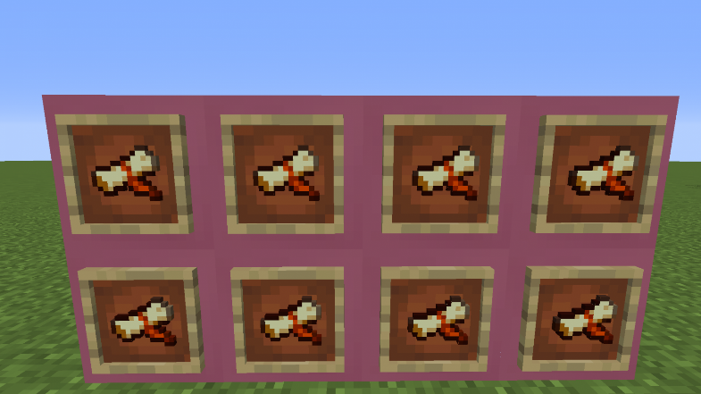

Today +CHILDNAME+ used their creative writing skills to journey down the next development stage for +hisher+ epic movie!

If you like to read and you like to watch movies, you’ve probably thought that you could write a movie yourself. Have you? Be honest!

In this session +CHILDNAME+ weaved together an interesting story +heshe+ wanted to tell within their newly created film set. We covered the basics of script/concept writing in a nutshell to help kickstart the storytelling process. There is much more to learn as we progress and experiment, but this initial mind map got  +CHILDNAME+ pointed in the right direction.

Telling a fun and engaging story is no easy task! It takes some trial and error to get things right which is why planning is crucial. +HESHE+ can get as creative is possible in this exercise, something that we love to actively encourage. We also implemented a sprinkle of social work and collaboration as +CHILDNAME+  invited other ninjas to provide some additional acting talent, by way of character voicing or custom sound effects!

In the end we had a script worthy of an academy award (after a few more tweaks) Next it was time to put all this preparation into action! Well done so far +CHILDNAME+!

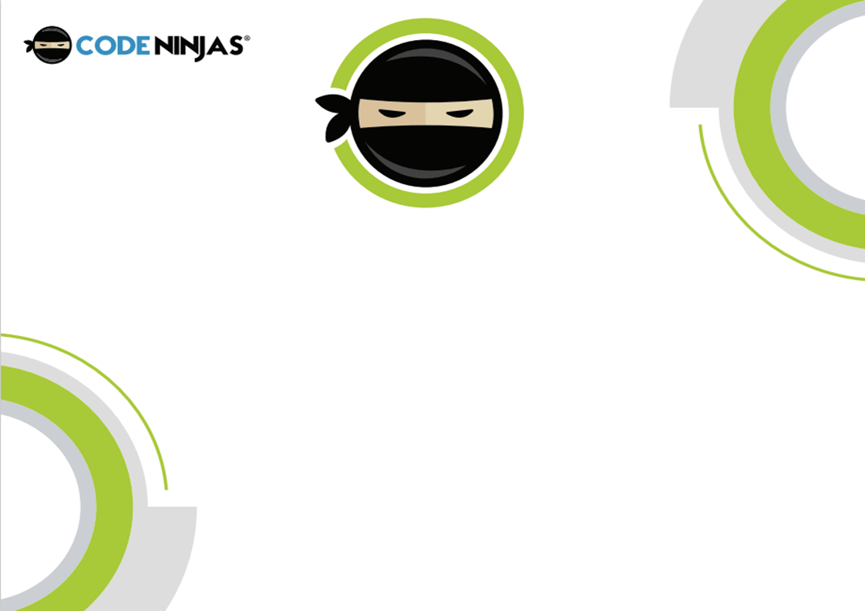

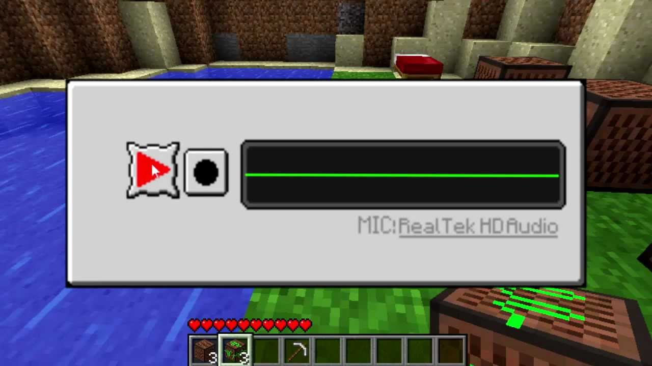

Now we’ve got a set and a script, we need some voices! For this session, me and +CHILDNAME+ explored bringing our script to life!

If countless hours of watching their favourite YouTubers have taught them (and especially yourself after hearing the screeching) is that alongside the visual content, audio is paramount!

That's why we brought in some awesome headsets, sporting multicolored LED lighting in true gamer like fashion to capture +CHILDNAME+ ‘s compelling story. We began by recording whatever thoughts or stories came into +hisher+ head. Being able to help record thoughts, share a familiar story or even rehearse our new script is a great way to help build confidence on the microphone.

As much as we may want, our first takes are rarely one hit wonders, so we need to be patient with the process. This is why storyboarding and scripting is so important as they all factor into our prep work, even if we make some slight changes here or there.

We also explored some voice changing software so +CHILDNAME+ can edit their audio to resemble an alien voice, an echo of a large space, being underwater and everything in between! Fantastic work today superstar!

